IAPL AGM 2023 – Washington DC
Wednesday, 18 October 2023 – Sunday 22, October 2023

HOTEL BOOKING
The Westin, Georgetown, Washington DC
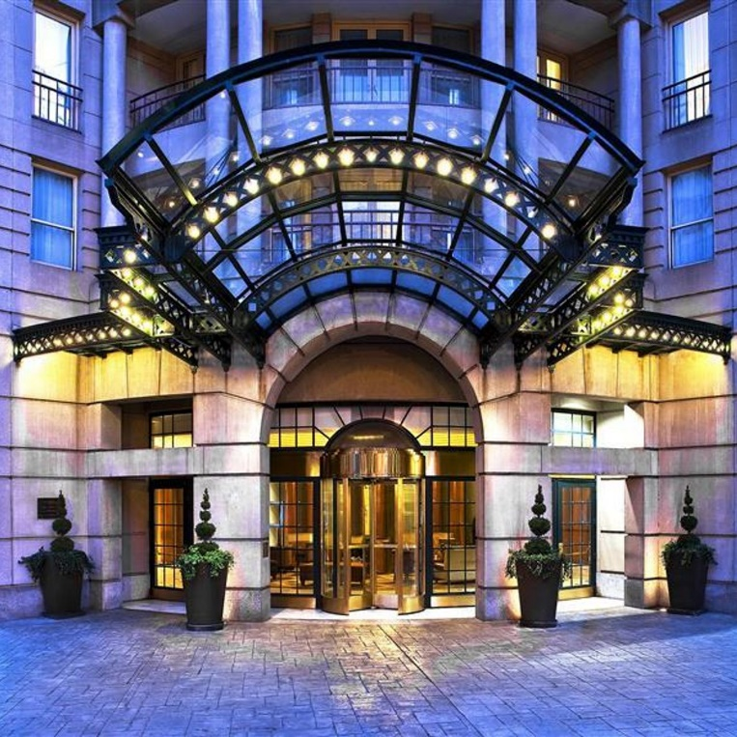

https://www.marriott.com/en-us/hotels/wastw-the-westin-georgetown-washington-dc/overview/

Making a Reservation:
Call: 1-888-627-8406 or online via the following link:
Book your group rate for IAPL Conference room block Rev.Oct2023:

PLEASE NOTE: The specially negotiated rate is available for IAPL members and guests until
CUT OFF DATE: Wednesday, September 13, 2023
After this date any guest(s) looking to make a reservation will be subject to the best available rate at that time.
Key Hotel Information:

Check in Time: 3:00pm
Check out time: 12:00pm
Cancellation Policy: Cancellations must be received at least 72 hours prior to arrival in order to avoid a cancellation fee equivalent to 1-night room and tax.
Internet: $12.95US daily in Guestrooms, complimentary in Lobby
Pet Policy: We are a pet friendly hotel however we do request that you advise us of your furry family member prior to arrival so that we can secure the appropriate room for you, $25 daily fee.
Self-Parking: $48US Daily
Valet Parking: $58US Daily
Room Types: Please note that this block consists of standard rooms so the bed type selection is not guaranteed. If you require rooms with 2 beds please let us know as soon as possible to see if we can include them. Also note that in order to guarantee rooms with 2 beds the rate for that room type will increase by $20 per night.

